**GIT**

**Handson5 GIT-HOL**

# Git Merge & Conflict Resolution - Step by Step Execution

## Step 1: Navigate to the Git Repository

Open Git Bash and navigate to the GitDemo repository.

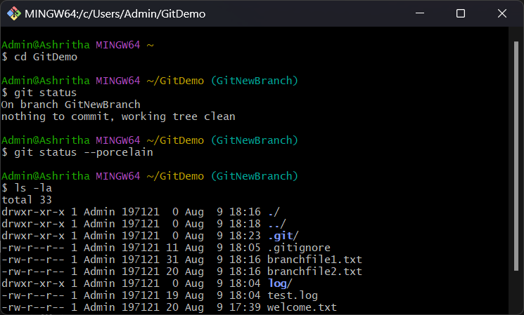

## Step 2: Check Git Status

Check the current status to ensure you are on the correct branch (GitWork).

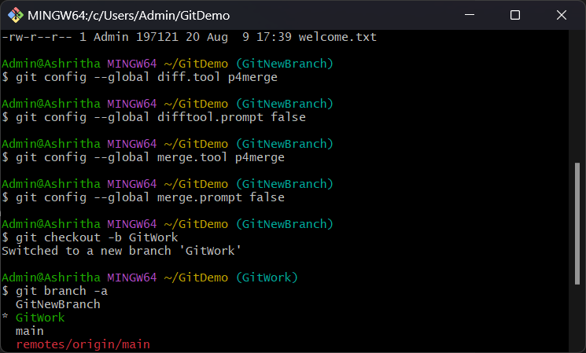

## Step 3: Stage and Commit Changes

Stage any changes and commit them before merging to ensure a clean working directory.

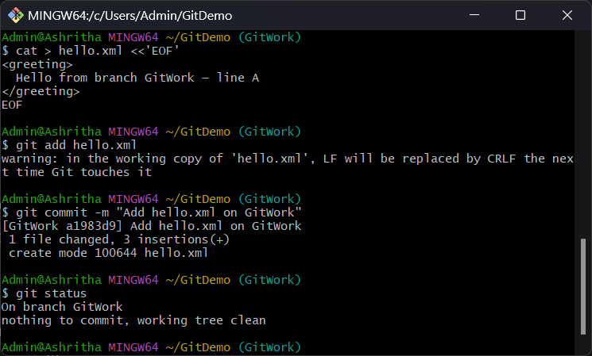

## Step 4: Switch to Main Branch

Switch from GitWork branch to main branch to prepare for merging.

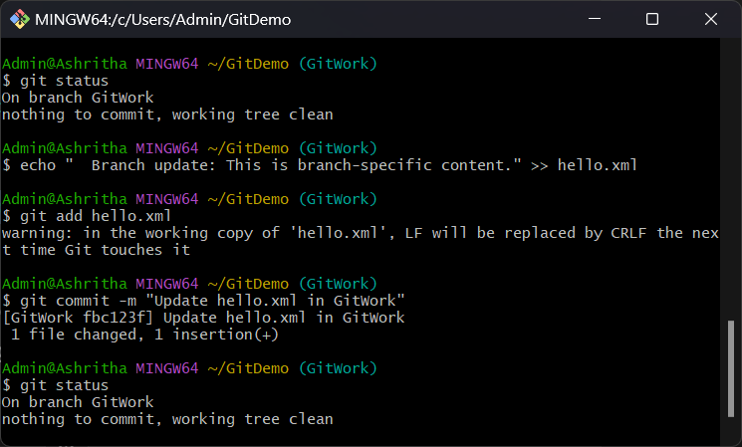

## Step 5: Pull Latest Changes

Pull the latest changes from the remote main branch to ensure it is up to date.

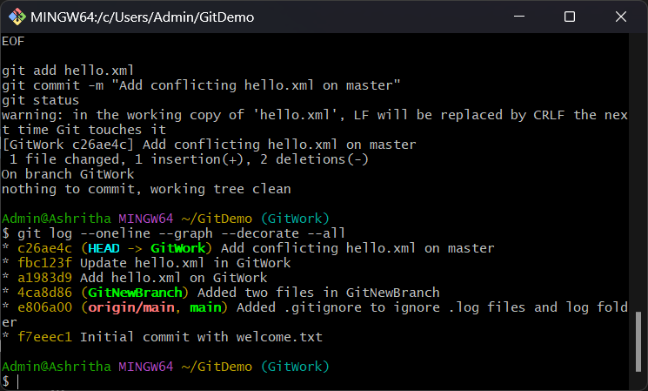

## Step 6: Merge GitWork into Main

Merge the changes from GitWork branch into the main branch.

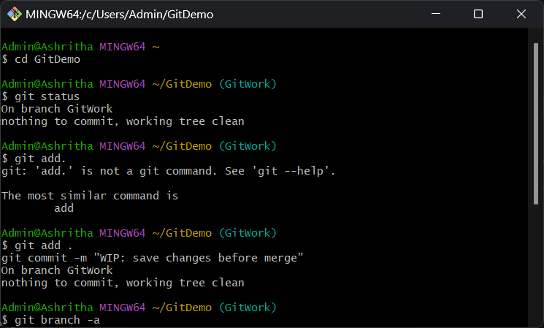

## Step 7: Merge Completed

Verify that merge is successful and no conflicts remain.

